

Custom SSL Certificate

Requesting a SAN enabled SSL Certificate

Andrei Alex | GITO-MS Server | 21.06.2017

# Procedure

These first steps are all performed on the client IIS server

* 1. Open a root console and add the certificates snap-in

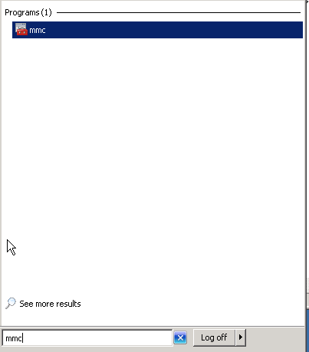

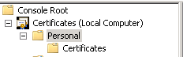

Make sure that the certificates snap-in points to the computer account.

* 2. 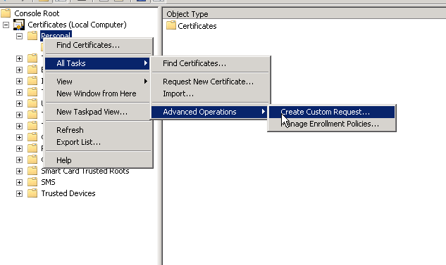

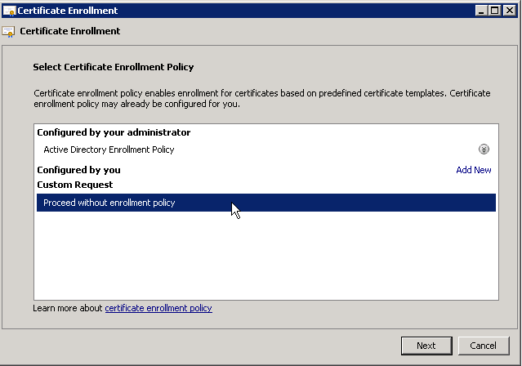

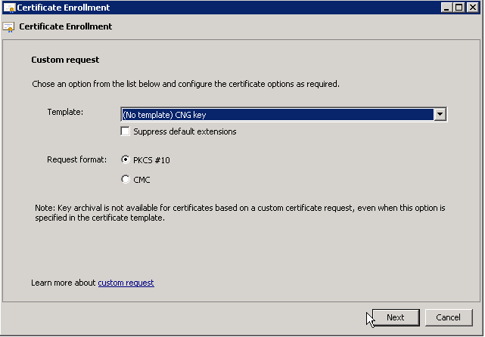

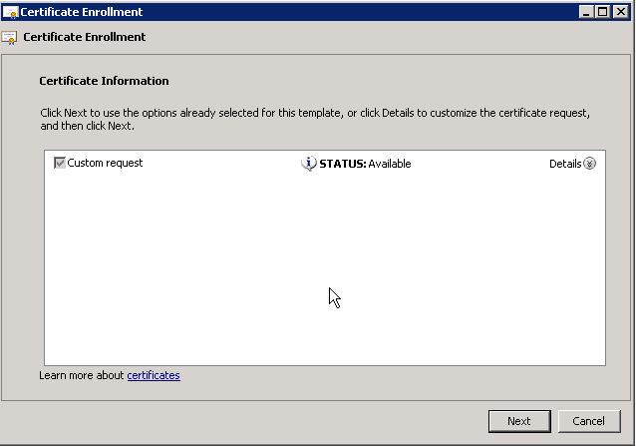

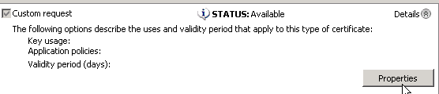

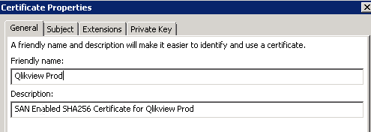

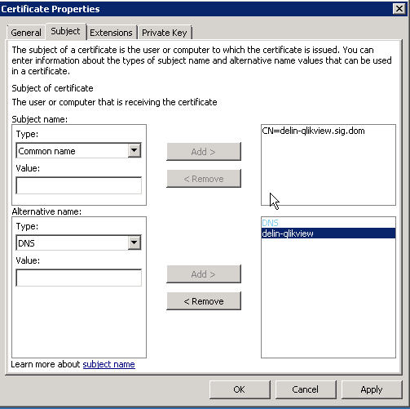

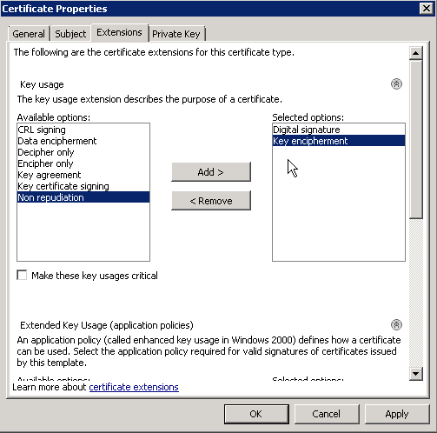

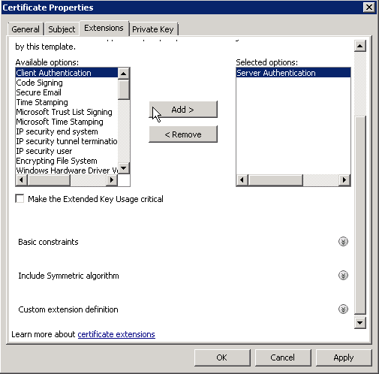

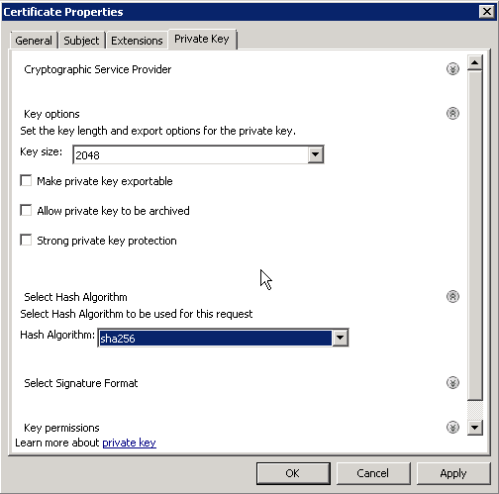

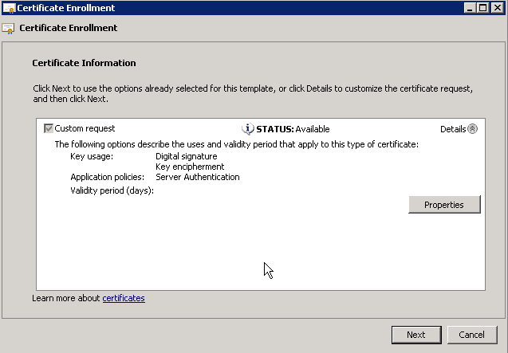

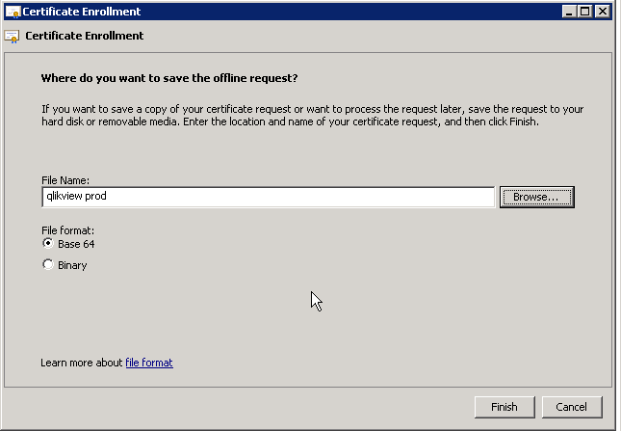

* This is the procedure I followed for creating the certificate for both the dev and productive servers for QlikView.
  + <https://delin-qlikview-dev.sig.dom/QlikView/>
  + <https://delin-qlikview.sig.dom/QlikView/>
* After creating this request we follow the normal steps for creating an SSL certificate. (Connect to <https://delinvmas139.sig.dom> and use the REQ file created for the request using the SIG-WebServer Template – It does NOT overwrite the custom fields. )